UNEARTHING THE ENVIRONMENTAL IMPACT OF HUMAN ACTIVITY: A GLOBAL CO2 EMISSION ON ANALYSIS

1.INTRODUCTION

Overview:

We are becoming more and more aware of how our actions are damaging our planet. There has been a wide spread of the mindset in reducing carbon emissions, and we are no strangers to the sense of urgency. However, amongst the sheer panic and the overwhelming amounts of information on how to reduce our carbon footprint, many of us are left confused as to why this is such an important matter and how carbon dioxide affects us.

Purpose:

Over the last century, burning of fossil fuels like coal and oil has increased the concentration of atmospheric carbon dioxide (CO2). This increase happens because the coal or oil burning process combines carbon with oxygen in the air to make CO2. To a lesser extent, clearing of land for agriculture, industry, and other human activities has increased concentrations of greenhouse gases.The industrial activities that our modern civilization depends upon have raised atmospheric carbon dioxide levels by nearly 50% since 1750.

PROBLEM DESTINATION AND DESIGN THINKING

Empathy map:

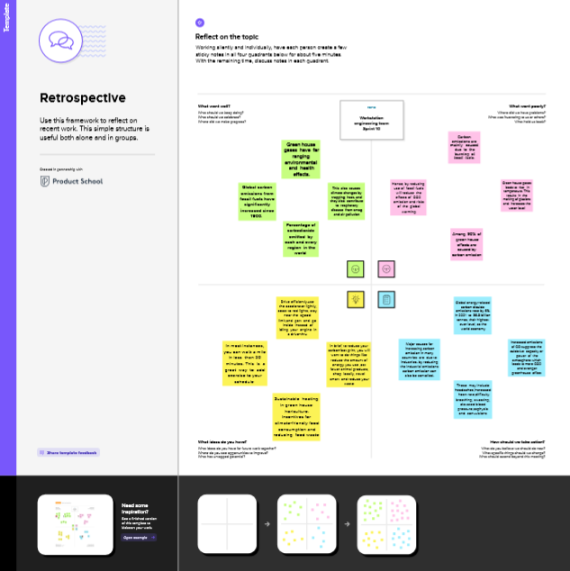

Brainstorming

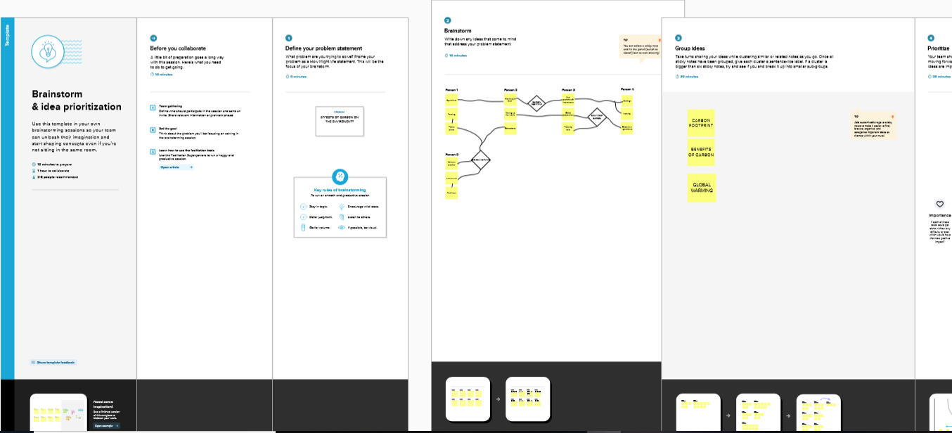

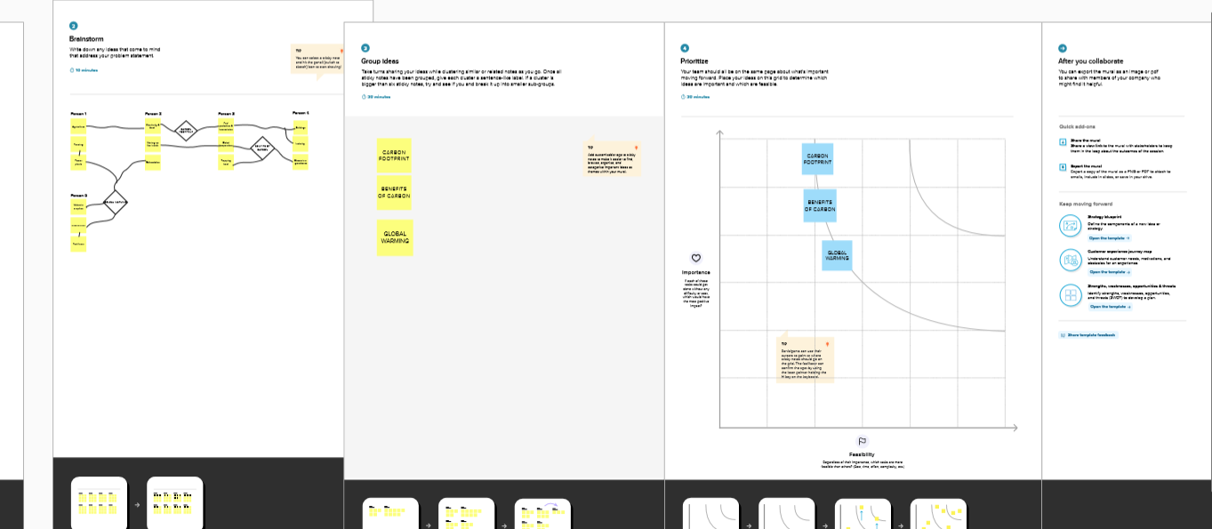

RESULT

Dashboard:

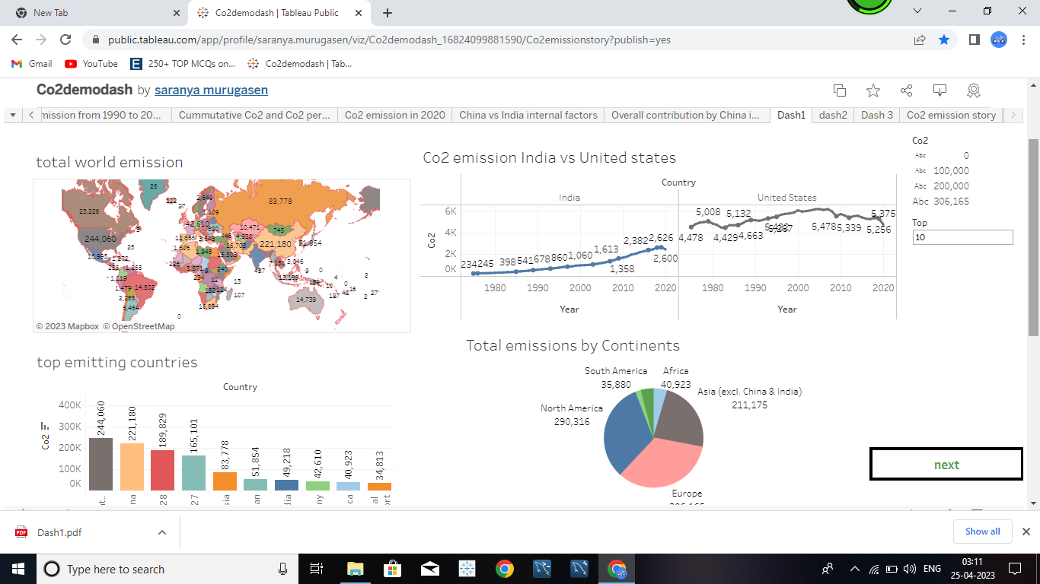

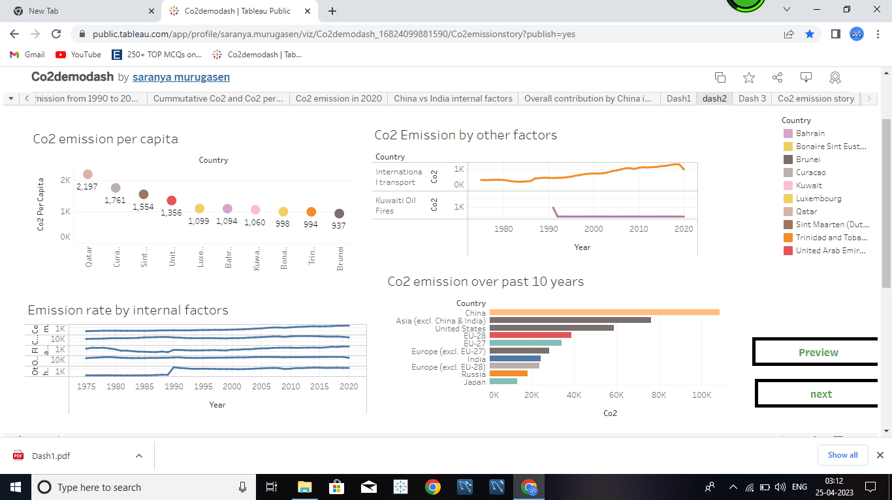

Story: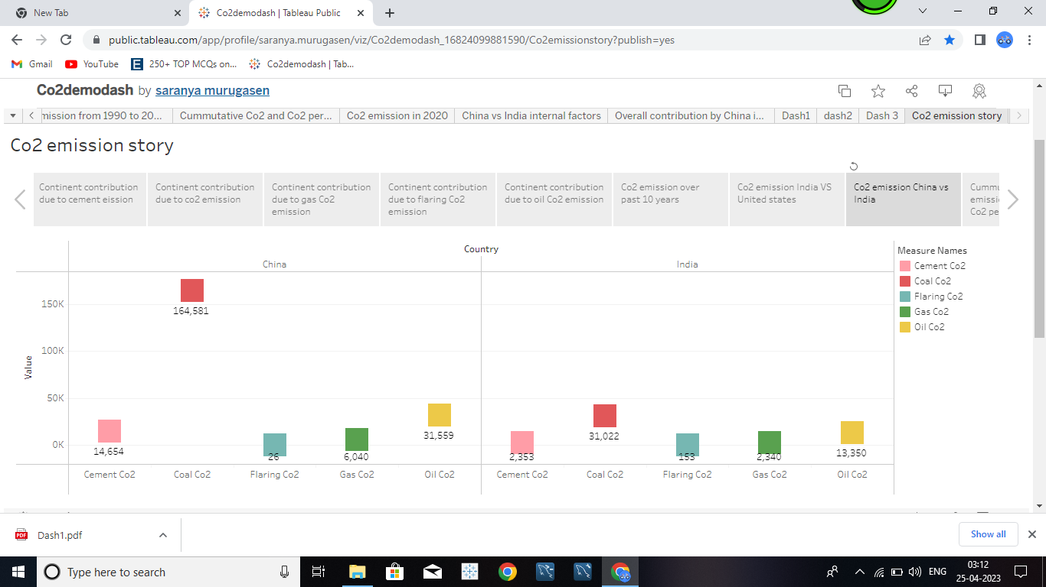

ADVANTAGES OF CO2 EMISSION

* The global food industry depends on CO2 for short-term and long-term refrigeration of food products.
* The Endowment for Medical Research cites university studies that show increasing the level of CO2 to 550 parts per million (ppm) speeds up plant growth as much as 40 percent in a controlled greenhouse environment
* During the summer, opening the ventilation system allows fresh air into the greenhouse, which increases the CO2 level.
* However, during the winter, in northern regions, the circulation of cold outside air into heated greenhouses could kill plants.

DISADVANTAGES OF CO2 EMISSION

* High carbon dioxide levels can cause poor air quality and can even extinguish pilot lights on gas-powered appliances.
* The main disadvantage of the carbon credit is precisely in this exchange market.
* Some institutions and countries can accommodate themselves in this market to continue emitting their greenhouse gases.
* They do not invest in actions to avoid emissions because they are able to buy unlimited credits.

APPLIANCES

* It is more common for companies to get involved in this process of neutralizing emissions and purchasing carbon credits. Even large global companies participate in this movement, including Apple, Google, Microsoft, Mercedes-Benz and Unilever. In Brazil, Natura put into practice the Carbon Neutral Program in 2007.
* Businesses are understanding the connection between environmental concerns and economic prosperity. Therefore, in addition to investing in sustainable initiatives, they are creating carbon neutralization goals. Projects are as varied as possible, and can be
* investment in renewable energy;
* zero waste;
* create biodegradable materials;
* creation of ecological cars;
* create a sustainable production chain;
* among others.

CONCLUSION

The use of carbon credit also needs to be thought of in a sustainable way. Understand that it is an alternative for emergency needs, not to rest on the fact that the other has saved.Everyone’s focus must be on reducing greenhouse gas emissions. Only in this way will it be possible to stop the negative impacts caused by global warming.

FUTURE SCOPE

* CO2 emissions from energy combustion grew by around 1.3% or 423 Mt in 2022, while CO2 emissions from industrial processes declined by 102 Mt.
* Emissions growth in 2022 was below global GDP growth (+3.2%), reverting to a decades-long trend of decoupling emissions and economic growth that was broken in 2021.
* The latter, which sees most emissions come from deforestation and peatland clearance, now says it will cut emissions levels by at least 31.89% by 2030. Globally, inadequate pledges put the world on a path to warm by 2.5C by 2100. Still, a 10.6% increase in emissions represents slight progress.